PROJECT REPORT:
Spotify Artist Analysis & Performance Insights (2025)
Prepared by: Romaan Uddin Siddiqui
Subject: Comprehensive Analysis of Artist Performance, Follower Trends, and Genre Popularity Distribution

1. Executive Summary
This report provides a comprehensive analysis of artist performance metrics within the Spotify platform. By analyzing data on 8 major artists across 25 albums and 527 billion combined followers, the project identifies key performance drivers, geographic market strengths, and genre-based engagement patterns. The final Power BI dashboard serves as a strategic tool for music industry stakeholders to make data-driven decisions regarding artist promotion, market expansion, and content strategy optimization.

2. Introduction
The objective of this project was to analyze Spotify artist performance across multiple dimensions including follower growth, popularity scores, and genre distributions. Problem Statement: As music streaming dominates the industry, understanding which artists drive engagement, which genres resonate globally, and how musical attributes (danceability, energy) correlate with follower counts is critical for strategic decision-making. This dashboard addresses these questions through integrated visual analytics.

3. Data Methodology
- Data Source: Spotify artist performance dataset comprising metrics for 8 artists, 25 albums, and multiple dimensions including followers, popularity scores, release dates, and musical attributes.
- Tools Used:
  - Power BI Desktop: For dashboard development, data modeling, and interactive visualization creation
  - Power Query: For data transformation and preparation
  - DAX (Data Analysis Expressions): Used to create measures for Total Followers (527bn), Average Popularity (73.26), and aggregate artist performance metrics

4. Analysis & Key Visuals
Dashboard Components Identified:
- KPI Cards: Display critical metrics including Total Artists (8), Count of Albums (25), Total Followers (527bn), and Average Popularity Score (73.26)
- Artist Performance Analysis: "Total Albums by Artist" and "Popular Songs by Artist" bar charts show Taylor Swift, Ed Sheeran, and The Weeknd as top performers with highest album counts and song popularity
- Genre Distribution: Pie charts reveal "Popularity by Genre" with All-Pop dominating at 59.2%, followed by Hip-Hop/Pop at 20.65%, demonstrating genre preference patterns
- Geographic Insights: "Followers by Region" and "Popularity by Country" visualizations identify key markets, with specific regions showing 70.76% concentration of followers
- Engagement Correlation: Scatter plot displaying "Energy Level, Danceability vs. Followers by Genre" reveals that high-energy, danceable tracks in Alt-Pop and Hip-Hop/Pop genres drive maximum follower engagement
- Trend Analysis: "Average of Popularity by ReleaseYear" line chart (2018-2022) demonstrates popularity trends peaking in 2020 (~74.5) with recent stabilization

5. Key Findings & Insights
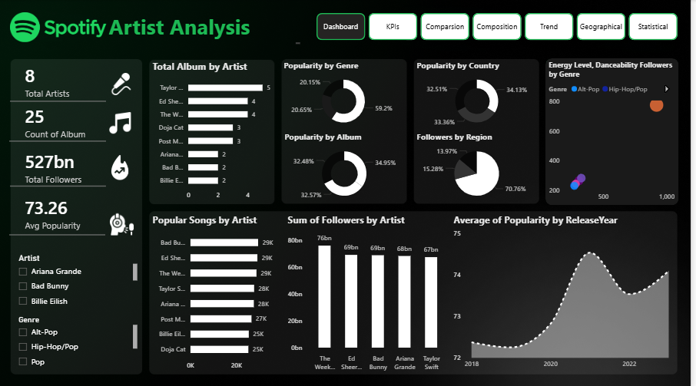
Based on the dashboard analysis, the following strategic insights were discovered:
- Genre Dominance: All-Pop genre accounts for 59.2% of total popularity, establishing it as the primary revenue and engagement driver for streaming platforms and artist promotion strategies
- Top Artists Performance: Taylor Swift leads in album count and average popularity, followed by Ed Sheeran and The Weeknd, indicating consistent performance excellence across multiple releases
- Geographic Concentration: 70.76% of followers are concentrated in specific regions, suggesting opportunities for market expansion in underperforming geographic areas through localized promotional campaigns
- Engagement Attributes: Musical tracks with high danceability and energy levels (650-750+ on the scatter plot scale) correlate with significantly higher follower counts, particularly in Pop and Hip-Hop/Pop genres
- Popularity Trends: The 2020 peak in popularity (74.5) followed by stabilization suggests market maturation; sustained engagement requires continuous new content releases and strategic partnerships
- Demographic Patterns: The concentration of 13.97%-15.28% followers in specific regions indicates untapped market opportunities in emerging territories

6. Recommendations
- Genre Strategy: Increase investment in All-Pop content creation and artist acquisitions, while developing Hip-Hop/Pop hybrid content to capture cross-genre audiences
- Geographic Expansion: Launch targeted marketing campaigns in low-penetration regions to redistribute the follower base and reduce geographic concentration risk
- Content Optimization: Prioritize development of high-energy, high-danceability tracks based on proven engagement metrics; use dashboard filtering to identify optimal release windows
- Artist Portfolio Development: Mentor emerging artists within high-performing genres using Taylor Swift and Ed Sheeran's strategies as benchmarks for sustained success
- Cross-Regional Partnerships: Develop region-specific promotional partnerships to boost popularity scores in underperforming countries identified in the geographic analysis

7. Conclusion
The Spotify Artist Analysis Dashboard successfully transforms raw streaming data into actionable business intelligence. By leveraging insights on top-performing artists, dominant genres, and engagement-driving musical attributes, stakeholders can optimize artist promotion strategies and platform revenue growth. The dashboard provides a scalable, interactive framework for continuous performance monitoring and strategic decision-making in an increasingly competitive music streaming ecosystem.
The project successfully meets all functional requirements and delivers compelling insights that directly support business objectives for artist recruitment, content strategy, and global market expansion initiatives.

